# 3.4 The Unit Vector in 3-Dimensions and Vectors in Standard Position

## THE UNIT VECTOR IN 3-DIMENSIONS

The unit vector, as you will likely remember, in 2-dimensions is a vector of length 1. A unit vector in the same direction as the vector $\vec{v}$ is often denoted with a “hat” on it as in $\hat{v}$. We call this vector “v hat.”

The unit vector $\hat{v}$ corresponding to the vector $\vec{v}$ is defined to be

$$\hat{v}=\frac{\vec{v}}{\left\|\vec{v}\right\|}$$

The unit vector corresponding to the vector $\vec{v}=\left\langle -8,\left.12\right\rangle \right.$ is

Example (1)

$$\hat{v}=\frac{\vec{v}}{\left\|\vec{v}\right\|}$$

$$\hat{v}=\frac{\left\langle -8,\left.12\right\rangle \right.}{\sqrt{{\left(-8\right)}^{2}+{\left(12\right)}^{2}}}$$

$$\hat{v}=\frac{\left\langle -8,\left.12\right\rangle \right.}{\sqrt{64+144}}$$

$$\hat{v}=\frac{\left\langle -8,\left.12\right\rangle \right.}{\sqrt{208}}$$

$$\hat{v}=\left\langle \frac{-8}{\sqrt{208}},\left.\frac{12}{\sqrt{208}}\right\rangle \right.$$

A unit vector in 3-dimensions and in the same direction as the vector $\vec{v}$ is defined in the same way as the unit vector in 2-dimensions.

The unit vector $\hat{v}$ corresponding to the vector $\vec{v}$ is defined to be $\hat{v}=\frac{\vec{v}}{\left\|\vec{v}\right\|}$, where $\vec{v}=\left\langle x,\left.y, z\right\rangle \right..$

For example, the unit vector corresponding to the vector $\vec{v}=\left\langle 5,\left.-3, 4\right\rangle \right.$ is

$$\hat{v}=\frac{\vec{v}}{\left\|\vec{v}\right\|}$$

$$\hat{v}=\frac{\left\langle 5,\left.-3, 4\right\rangle \right.}{\sqrt{5^{2}+{\left(-3\right)}^{2}+4^{2}}}$$

$$\hat{v}=\frac{\left\langle 5,\left.-3, 4\right\rangle \right.}{\sqrt{25+9+16}}$$

$$\hat{v}=\frac{\left\langle 5,\left.-3, 4\right\rangle \right.}{\sqrt{50}}$$

$$\hat{v}=\frac{\left\langle 5,\left.-3, 4\right\rangle \right.}{5\sqrt{2}}$$

$$\hat{v}=\left\langle \frac{5}{5\sqrt{2}},\left.\frac{-3}{5\sqrt{2}},\frac{4}{5\sqrt{2}}\right\rangle \right.$$

## VECTORS IN STANDARD POSITION

A vector with its initial point at the origin in a Cartesian coordinate system is said to be in *standard position*. A common notation for a unit vector in standard position uses the lowercase letters i, j, and k is to represent the unit vector in

the $x$-direction with the vector $\hat{i}$, where $\hat{i}=\left\langle 1,\left.0, 0\right\rangle \right.$, and

the $y$-direction with the vector $\hat{j}$, where $\hat{j}=\left\langle 0,\left.1, 0\right\rangle \right.$, and

the $z$-direction with the vector $\hat{k}$, where $\hat{k}=\left\langle 0,\left.0, 1\right\rangle \right.$.

The figure shows these three unit vectors.

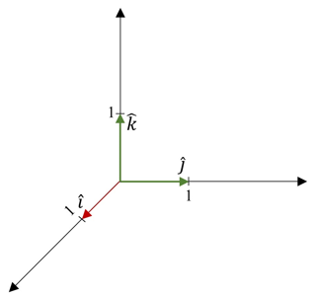

Any vector can be expressed as a combination of these three unit vectors.

The vector $\vec{v}=\left\langle 5, \left.4, 7\right\rangle \right.$ can be expressed as $\vec{v}=5\hat{i}+4\hat{j}+7\hat{k}$.

Example (2)

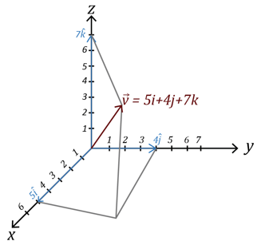

Now, the unit-vector in the direction of $\vec{v}=5\hat{i}+4\hat{j}+7\hat{k}$ is

$$\hat{v}=\frac{\vec{v}}{\left\|\vec{v}\right\|}$$

$$\hat{v}=\frac{\left\langle 5,\left.4, 7\right\rangle \right.}{\sqrt{5^{2}+4^{2}+7^{2}}}$$

$$\hat{v}=\frac{\left\langle 5,\left.4, 7\right\rangle \right.}{\sqrt{25+16+49}}$$

$$\hat{v}=\frac{\left\langle 5,\left.-3, 4\right\rangle \right.}{\sqrt{90}}$$

$$\hat{v}=\frac{\left\langle 5,\left.4, 7\right\rangle \right.}{\sqrt{9∙10}}$$

$$\hat{v}=\frac{\left\langle 5,\left.4, 7\right\rangle \right.}{3\sqrt{10}}$$

$$\hat{v}=\left\langle \frac{5}{3\sqrt{10}},\left.\frac{4}{3\sqrt{10}},\frac{7}{3\sqrt{10}}\right\rangle \right.$$

$$\vec{v}=\frac{5}{3\sqrt{10}}\hat{i}+\frac{4}{3\sqrt{10}}\hat{j}+\frac{7}{3\sqrt{10}}\hat{k}$$

## NORMALIZING A VECTOR

Normalizing a vector is a common practice in mathematics and it also has practical applications in computer graphics.

Normalizing a vector $\vec{v}$ is the process of identifying the unit vector of a vector $\vec{v}$.

## EXAMPLES

1. Write the unit vector that corresponds to $\vec{v}=\left\langle 2,\left.-3, 4\right\rangle \right..$

ANS: $\frac{2}{\sqrt{29}}\hat{i}-\frac{3}{\sqrt{29}}\hat{j}+\frac{4}{\sqrt{29}}\hat{k}$

1. Write the unit vector that corresponds to $\vec{v}=\left\langle 1,\left.-1, 1\right\rangle \right.$.

ANS: $\frac{1}{\sqrt{3}}\hat{i}-\frac{1}{\sqrt{3}}\hat{j}+\frac{1}{\sqrt{3}}\hat{k}$

1. Write the unit vector that corresponds to $\vec{v}-\vec{u }=\left\langle 6,\left.7, 2\right\rangle \right.-\left\langle 2,\left.7, 6\right\rangle \right..$

ANS: $\frac{1}{\sqrt{2}}\hat{i}-\frac{1}{\sqrt{2}}\hat{k}$

1. Normalize the vector $\vec{v}=\left\langle 4,\left.3, 2\right\rangle \right.$.

ANS: $\frac{4}{\sqrt{29}}\hat{i}+\frac{3}{\sqrt{29}}\hat{j}+\frac{2}{\sqrt{29}}\hat{k}$

## USING TECHNOLOGY

We can use technology to find the unit vector in the direction of given vector.

Go to www.wolframalpha.com.

Use WolframAlpha to find the unit vector in the direction of $\vec{u}=\left\langle 5,\left.4, 3\right\rangle \right.$. In the entry field enter normalize <5,4,3> and WolframAlpha gives you an answer.

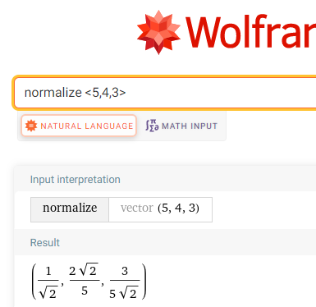

Translate WolframAlpha’s answer to $\frac{1}{\sqrt{2}}\hat{i}+\frac{2\sqrt{2}}{5}\hat{j}+\frac{3}{5\sqrt{2}}\hat{k}$.

## NOTE TO INSTRUCTOR

Consider working through these examples.

1. Write the unit vector that corresponds to $\vec{v}=\left\langle 9,\left.-2, 6\right\rangle \right..$

ANS: $\frac{9}{11}\hat{i}-\frac{2}{11}\hat{j}+\frac{6}{11}\hat{k}$

1. Write the unit vector that corresponds to $\vec{v}-\vec{u }=\left\langle 7,\left.-2, 8\right\rangle \right.-\left\langle 3,\left.3, 6\right\rangle \right..$

ANS: $\frac{4}{3\sqrt{5}}\hat{i}-\frac{\sqrt{5}}{3}\hat{j}+\frac{2}{3\sqrt{5}}\hat{k}$

1. Normalize the vector $\vec{v}=\left\langle 4,\left.-4, 5\right\rangle \right..$

ANS:

[3-4_the_unit_vector_in_3-dimensions.docx](https://oer4cte.org/math4gamedevelopers/teacher/3-4_the_unit_vector_in_3-dimensions.docx), attributed to Denny Burzynski (author) and Downey Unified School District (publisher) is licensed under CC BY-NC 4.0. To view a copy of this license, visit https://creativecommons.org/licenses/by-nc/4.0